**CHAPTER I**

**PROJECT LOCATION AND DESIGN BUILDING ORIENTATION**

**Introduction**

Air Conditioning has a big importance to daily lives to make sure everyone feel comfotable and happy while working hard. For hospital, it needs a functional Air-Conditioning System to stay operational. This is especially true for places like a clean room or an operating room. It provides a broad range of services in support of populations who are uniquely vulnerable to an elevated risk of health, fire, and safety hazard. These heavily regulated, high-stakes facilities undergo continuous maintenance, verification and inspection; typically operate 24hours/day, 7hours/week; and are health care organization for long life cycles. Hospital facilities and services are characterized by high rates of modification because of the continuously evolving science and economics of health care, and consume large quantities of energy and potable water. The often unique environmental conditions associated with these facilities, and the critical performance, reliability and maintainability of Air-Conditioning Systems necessary to their success, demand a specialized set of engineering practices and design criteria established by technical standards and guidelines like in accordance with the procedures outlined in the American Society of Heating, Refrigerating, and Air-Conditioning Engineers (ASHRAE) Handbook of Fundamentals.

It is important to follow the design considerations for the hospital to create a comfortable environment for occupants and patients. Hospital air conditioning and ventilation systems are tasked with controlling temperature, air flow, air quality and humidity. It is essential to the healing and recovery process. Also, it works with in close coordination with specific medical practices. One example for the design of operating rooms which has specific requirements that include pressurization and higher levels of air filtration in addition to temperature and humidity control.

The design of the Three Storey Hospital Building would most be beneficial to the patients who are injured and sick and provide a comfortable environment in facilitating for healing and recovery. The design of the Air-Conditioning System would also benefit to the students who are taking the subject of Air Condition and Ventilation System (ME-517) which may serve as a reference material and the standards for the requirements of designing a hospital. And for the future researchers who are interested to that kind of matter, this material will help them to be a basis in their research especially for hospitals.

**Subject of the Report**

The subject of the report includes the following:

* Building Layout

This includes the presentation of the evaluation of climate conditions, building orientation, components and other factors that contribute to the cooling load of the conditioned space.

The layout of the building is included in the appendices.

* Load Calculation

Heating load calculations or cooling load calculations are used to identify the heating or cooling load capacity that a conditioned space needs to stay cool at summer and warm at winter. The process was developed by the Heating, Ventilating and Air Conditioning (HVAC) industries and has been used for decades to accurately design a heating and air conditioning equipment. In the ventilated space of the building, the block load maximum peak hour load calculation will be used.

Cooling load calculations using the procedures in ASHRAE manual and guide book with the selected indoor and outdoor conditions. The calculations include:

* External Load
* Internal Load

Also, it includes the presentation the psychrometric calculation for the selection of equipment.

* Ducting System

The ducting design layout is included in the appendices.

* Piping Design

The piping design layout is included in the appendices.

* A/C Equipment Selection

The design will utilize the use of chilled water type of airconditioning system and fan coil units. Also, split-type will be used on some spaces.

* System Cost Estimation

It is the approximation of the cost of the project which also includes engineering economic analysis. It employs the different methods for investment of capital and comparing alternatives which will be useful for selecting appropriate equipment for that system for cost minimization.

**Project Location and Design Building Orientation**

I. Climatic Condition of the Locality as to where the building is constructed.

The climatic condition in Batangas City for the summer design conditions is as follows:

* 1. Latitude = 13.7573° N latitude
  2. Longitude = 121.0517° East longitude
  3. Solar haze factor = 0; negligible
  4. Outdoor Conditions

4.1 Maximum dry bulb temperature, tDB = 35° C

4.2 Maximum wet bulb temperature, tWB = 26° C

* 1. Indoor Conditions

5.1 Dry bulb temperature tDB = 25° C

5.2 Relative humidity = 50%

* 1. Daily range in the locality = 10° C

II. Building Orientation

The building is to be located at Batangas-Tabangao-Lobo Rd., Barangay Pallocan West, Batangas City. The front elevation of the building is facing east and the rear is facing west.

* Location Map

Using the google earth application, the location map of the proposed site viewed by satellite is shown in Figure 5.0. It has a total perimeter of 171 m and total area of 1819 m2.

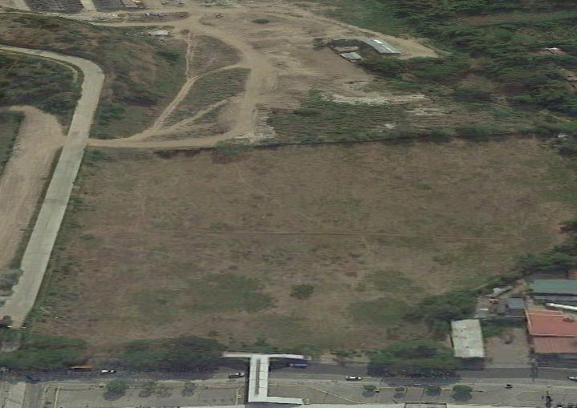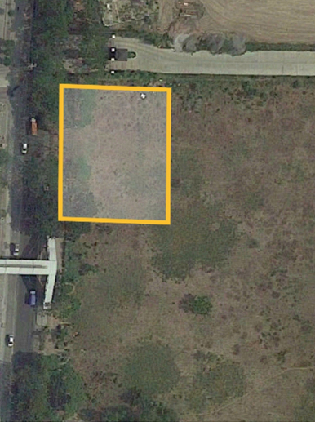

**Figure 1.0** Location Map of Barangay Pallocan West,

Batangas City by Google Earth

III.Building Representation

This section shows the 2D model of a three storey hospital building at Barangay Pallocan West, Batangas City. It includes the top view of each floor of the hospital.

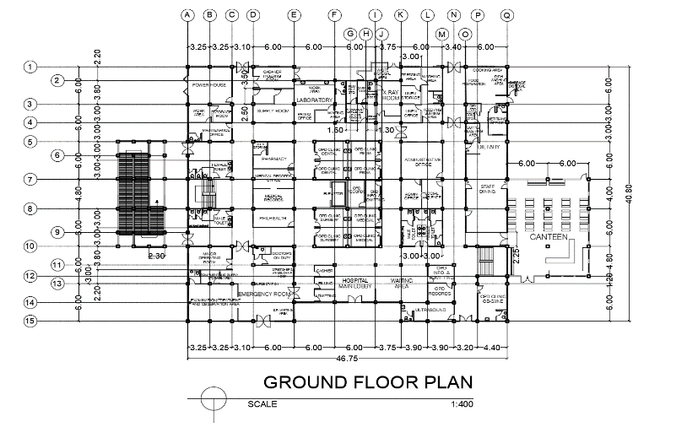

**Figure 2.0** Top View of the Ground Floor

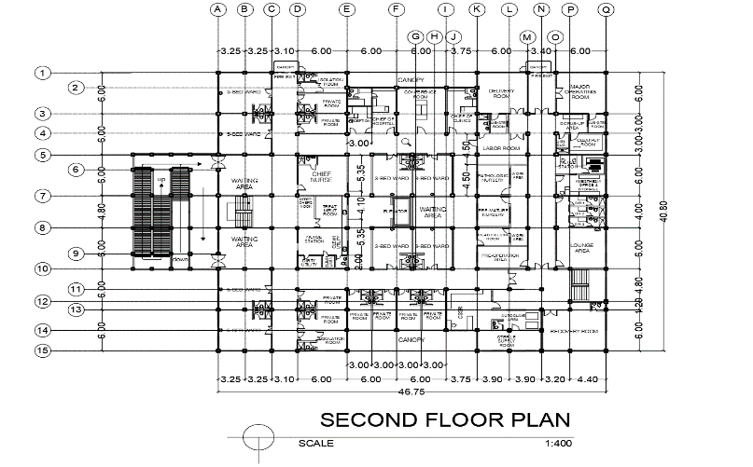

**Figure 3.0** Top View of the Second Floor

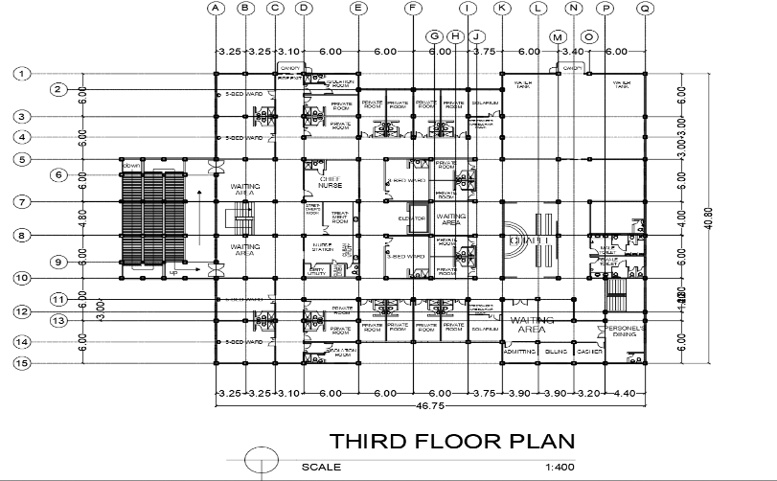

**Figure 4.0** Top View of the Third floor